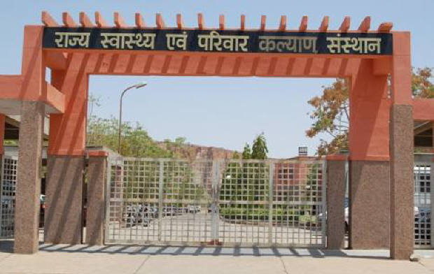

**SIHFW Rajasthan**

***Electronic Newsletter***

***October to December 2024*  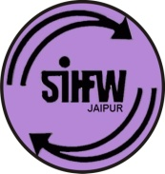**

SIHFW: an ISO 9001:2015 certified Institution

**From the Director’s desk…**

*Dear Friends…*

*New Year Greetings from SIHFW!!*

*Through this e-newsletter I want to wish all a very Happy New Year 2025. This newsletter will bring you all information on activities organised by SIHFW during October to December 2024. This year as per SDG Report of 2024 by UN, some findings have not been very progressive. The report says that The COVID-19 pandemic has ravaged global health, undoing nearly 10 years of progress in life expectancy. While most health-related indicators are moving in the right direction globally, current trends are insufficient to meet targets set for 2030. The COVID-19 pandemic turned back progress in life expectancy and gains in combating communicable diseases. Progress towards universal health coverage has slowed, leaving billions without care and subject to catastrophic costs and Declines in maternal mortality have stalled, with wide disparities by region and income. However some improvements are very promising and showing by 2030 how targets can be achieved. Such as, the report says-Under-5 deaths hit a record low in 2022; achieving the SDG target could save 9 million lives by 2030. The report also says-Efforts to combat communicable diseases have prevented millions of deaths. As Public Health professionals, we all work in hands with each other and collaborate for bringing these changes. With these commitments we can make this resolution and welcome the new Year 2025.*

*We would solicit your feedback and suggestions.*

*Best Wishes!!*

*Dr. O.P. Thakan*

*Director-SIHFW*

|  |  |
| --- | --- |
| *Some important health and social days for October to December 2024* | |
| October 1-31: Breast Cancer Awareness Month | November 18-24: World Antibiotic Awareness Week |
| October 1: World Vegetarian Day/International Day Of Older Persons | November 14: World Diabetes Day |
| October 10: World Mental Health Day/ World sight day | November 17: World Prematurity Day |
| October 12: World Arthritis Day | November 20: World Anti-Obesity Day |
| October 13: International Day Of Disaster Reduction | November 20: World Children’s Day/COPD Day |
| October 15: Global Hand washing Day | December 1: World AIDS Day |
| October 16: World Food Day/World Anesthesia Day | December 2: World Pollution Prevention Day |
| October 20: World Osteoporosis Day | December 3: International Day For Disabled Persons |
| October 24: World Polio Day | December 10: Human Right Day |
| November 1-30: Lung Cancer Awareness Month | December 12: Universal Health Coverage Day |
| November 12: World Pneumonia Day |  |

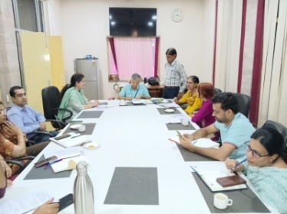**Staff Meetings**

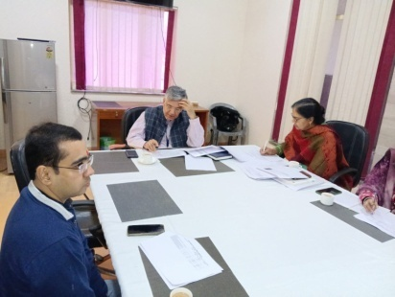Staff Meetings were organised at SIHFW under chairmanship of Director SIHFW. These meetings are organised to review training progress and give quality inputs in planning of all trainings in the State. These 3 meetings also provide opportunity for all coordinators for cross learning from each other. Following are the dates:

1. October 17, 2024
2. November 6, 2024
3. 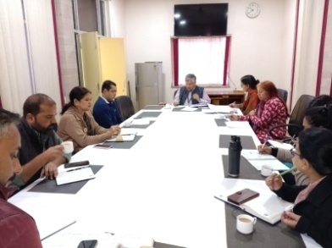December 16, 2024

**NCD Review Meeting**

During last 3 months, 6 NCD review meetings were organized at SIHFW and 102 members have participated in these meetings.

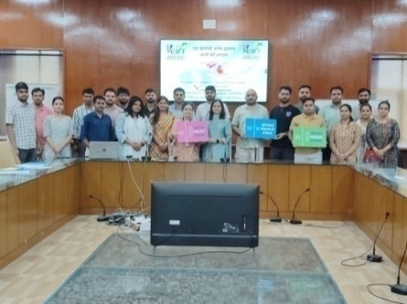**Regular Sessions on Organ Donation at SIHFW**

Sessions on Organ Donation are being organised at SIHFW in every training batch. Participants are oriented about the organ donation, legal provisions and clinical conditions for organ donation and procedure for registration. Sessions are delivered by experts from Mohan Foundation (NGO specialising in work of organ donation).

**Trainings at SIHFW**

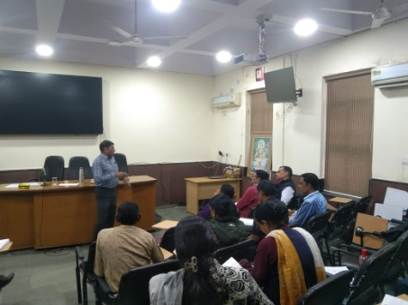**Training of Trainers (ToT)**

**ToT of District ASHA Trainers**

This training is at present longest duration training organized at SIHFW. This is a 15 days Hybrid training where 8 days online sessions are organized and 7 day offline sessions are organized at SIHFW. Training batch was organized during November 11 to 29, 2024 at SIHFW and 16 participants were trained in this batch. During offline sessions, participants are trained on skill hands-on practice, with skill demonstration. Participants appear in skill assessments based on OSCI, mock sessions and written paper. Only when participants qualify passing marks, they can become District trainers to give training to ASHA workers. Training methodology also includes Case discussions, written assignments, Role play, lecture methods, etc.

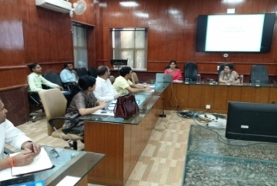**ToT on CAC**

This was a one day ToT organized on November 12, 2024. Specialists , Gynaecologists participated in this training. Participants trained in this training became trainers for CAC training.

**ToT IMNCI**

This ToT is of days and mix group of MD- PSM, Pediatricians, NT/NO/PHN, DPM/DAC etc participate in this training and become IMNCI trainers for ANMs and Nursing staff. During this training participants are taken for field visit for hands on learning to JK lone Hospital Jaipur. This is a 5 days training and six batches were organised at SIHFW and 144 participants were trained including DPM, DAC, Pediatricians, MD-PSM, NO, NT, PHN.

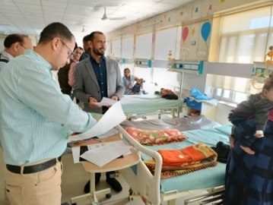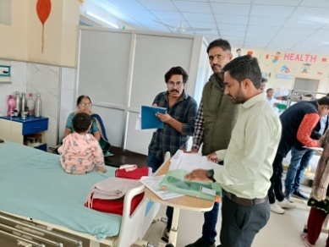

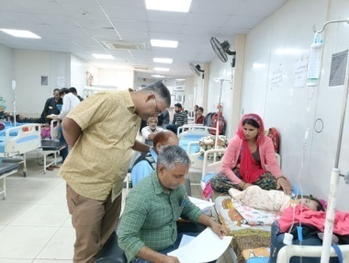

**ToT on Community Action for Health**

This was a 2 days ToT and 2 batches were organized on November 11-12, 2024 and November 13-14, 2024 and total 36 participants were trained in this training. Participants included DPM, DAC, BPM.

**ToT HBYC**

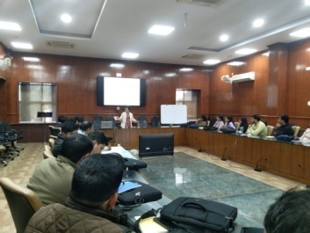HBYC ToT was organized at SIHFW, during last 3 months one batch was organized on October 8 -10, 2024 and 28 Sector Health Supervisors (SHS) were trained in this ToT.

**ToT on Bio-Medical Waste Management**

One day ToT on Bio Medical Waste was organised at SIHFW on December 20, 2024 and 45 participants were trained. Participants included MOs, Nursing staff and Waste Handlers.

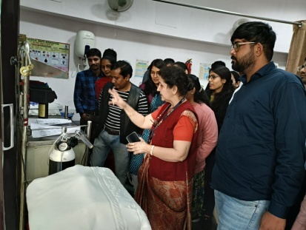**Foundation training of Newly Recruited Medical Officers**

This is a 12 day training provided to newly recruited Medical Officers. Objective of this training is to orient the newly recruited MOs to learn about the various health programmes and schemes, latest guidelines, Acts, rules and regulations and government procedures, which they have to perform as a Medical officer. The training focuses on sharpening administrative skills of MOs along with clinical roles and responsibilities. During October to December 2024, 3 batches of Foundation training were organized during October 14 to 26, 2024, November 18 to 30, 2024 and December 9 to 21, 2024. Total 93 Medical Officers were trained in these three batches.

Participants were also taken on field visits to observe UPHC Gandhinagar for Quality Assessment and Certification Process. Participants are given hands on exposure in skill lab of SIHFW on various work stations and with dummies.

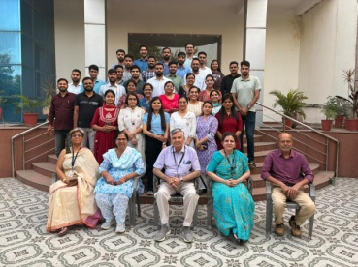

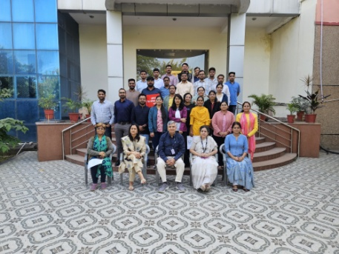

**Trainings under Immunization Program**

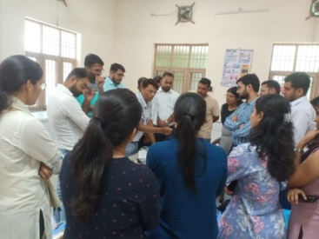**Routine Immunization Training for Medical Officers**

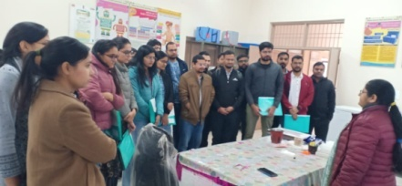Routine Immunization training is of 3 days duration organized for Medical Officers at SIHFW. Training batches always scheduled such that first day of training is on Tuesday so that participants get an exposure visit of Routine Immunization session planned on Thursdays (MCHN day). Immunization schedule, AEFI, Cold chain, Vaccine Management etc are the components of this training. 8 batches have been organized at SIHFW during last 3 months and 157 Medical Officers were trained.

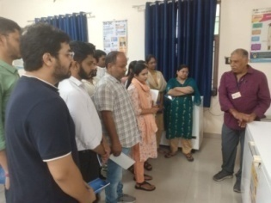

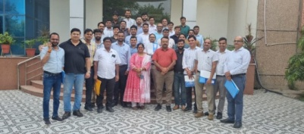

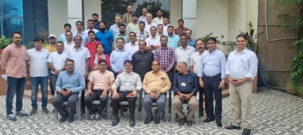

**Orientation for BCMOs**

Two days training –Orientation on Cold Chain for Block level Officials is organized at SIHFW. BCMOs and Medical Officers participate in this training. During last 3 months 5 batches were organized and 132 participants were trained in this.

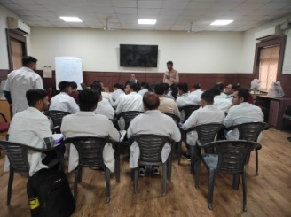**Trainings on Malaria Microscopy**

Malaria Microscopy

Three batches of Malaria microscopy training were organized at SIHFW in last 3 months. In this 5 days training for Lab assistants and Lab technicians are trained in these trainings. 74 participants were trained in last 3 months.

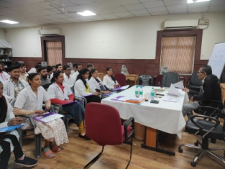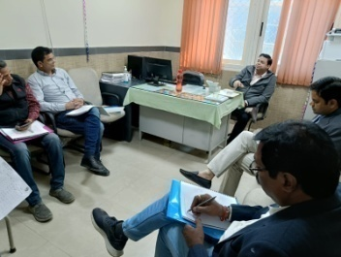**NPPC Training –visit to SMS**

**Trainings under Quality Assurance Program**

Training on National Quality Assurance Service (NQAS) was organized at SIHFW on October 28-30, 2024 and 64 participants were provided training. Participants included BCMO, MO, NO, SNO participated in this training.

**NQAS training on AEFI**

Specialised training on NQAS for AEFI was organized at SIHFW for RCHO and NQAS assessors on October 7 and 8, 2024 in 2 batches. 85 participants were trained in these trainings.

**IQVIA training for Tuberculosis Officers**

This was a one day training and 2 bathes were organized at SIHFW on December 11 and December 12, 2024. 88 participants were trained. District Tuberculosis Officials were participants.

**Training on Mental Health for Medical Officers (NMHP)**

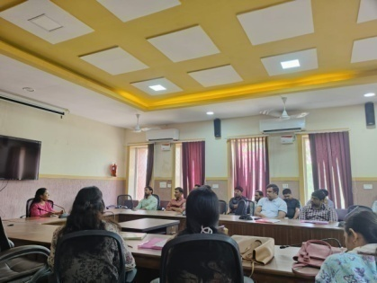

This is a five day training of Medical Officers focused onSuicide Prevention and management. 6 batches have been organised by SIHFW and Medical Officers are trained in these training batches. Participants are taken for a visit to Psychiatric centre, SMS, Jaipur and they are provided case studies which are discussed and analysed through discussions. 148 participants were trained in these 6 batches during last 3 months.

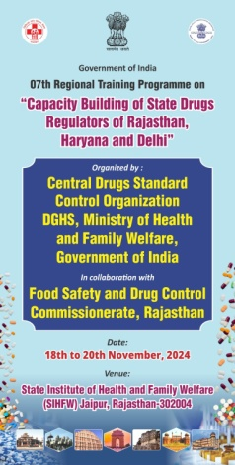**National Level Training - Capacity Building of State Drugs Regulators**

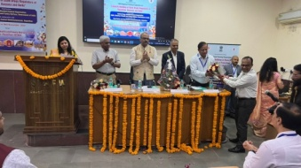This was a national level training-Regional training program on Capacity Building of State Drugs Regulators of Rajasthan, Haryana and Delhi. It was organised on 18th to 19 November 2024. It was organised by Central Drugs Standard Control Organisation DGHS, Ministry of Health and Family Welfare, Government of India in collaboration with Food Safety and Drug Control Commissionerate, Rajasthan. Drug regulators of 3 states-Rajasthan, Haryana and Delhi were participants in this training and 79 were trained.

**ASHA Handbook training**

Refresher training of Handbook is organized under ASHA Program. This is a two day training organized for ASHA mentoring and facilitation staff including ANM/SHS, etc. This training develops better supervision skills in facilitators to provide hand holding for ASHA workers. During last 3 months 4 batches were organized and 199 participants were trained.

**NSSK training**

These training are of two days and are organized for ANM and Staff Nurses. These trainings are organized at District level but for Bharatpur zone batches are organized at SIHFW. NSSK batches for ANM 2 batches were organized and 70 ANM were trained. NSSK for Staff Nurse training, 2 batches were organized and 46 participants were trained.

**Training of Dental MO under NOHP**

This is a one day training of Dental Medical Officers under National Oral Health Program. This training is organized at SIHFW. 2 batches was organized on September 30, 2024 and October 1, 2024. Total 127 participants were trained in these two batches.

**Field Trainings organized by SIHFW**

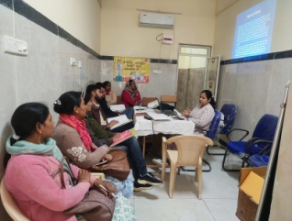**Comprehensive Abortion Care (CAC)**

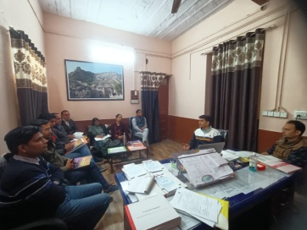Training on Comprehensive Abortion Care (CAC) is organised at District or equivalent hospitals, for 12 days. During last 3 months, 34 batches of CAC training were organised at Jhalawar, Rajsamand, Phalodi, Gangapurcity, (these are the selected training venues). Medical Officers are provided this training. This is a complete hands-on training.

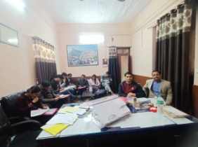

**Medical Method of Abortion (MMA) Training**

This is a clinical training organized at District Hospitals for Medical Officers. 17 batches have been completed in last 3 months. MMA training was organized at Medical College level by SIHFW.

**Laparoscopic Sterilization**

This training is organized for doctors/ specialist at Districts. 2 batches have been completed will December 2024.

**AAM Expanded Services Training**

These training are provided to various cadres under Ayushman Bharat Program, working at Ayushman Arogya Mandir. These cadres are Medical Officer, CHO, ANM, Staff Nurse and ASHA. Participants are provided training on key components of Mental and Neurological Substance Abuse, Elderly, Palliative, Oral, Eye, ENT and Emergency Care.

**RI for HW**

Routine Immunization training for Health workers is of 2 days duration and is organized at Districts for Health workers-ANM, GNM, LHV and Nursing staff. Participants are oriented on Routine Immunization schedule, AEFI, cold chain management, vaccine storage and micro planning of routine immunization, social mobilization and reporting mechanism. 8 batches have been completed in this training at Districts.

**Health News**

**Persistent infection can cause cervical cancer in women**

Cervical cancer develops in a woman's cervix (the entrance to the uterus from the vagina).  Almost all cervical cancer cases (99%) are linked to infection with high-risk human papillomaviruses (HPV), an extremely common virus transmitted through sexual contact. Although most infections with HPV resolve spontaneously and cause no symptoms, persistent infection can cause cervical cancer in women. Cervical cancer is the fourth most common cancer in women. In 2022, an estimated 660 000 women were diagnosed with cervical cancer worldwide and about 350 000 women died from the disease.

Effective primary (HPV vaccination) and secondary prevention approaches (screening for, and treating precancerous lesions) will prevent most cervical cancer cases. When diagnosed, cervical cancer is one of the most successfully treatable forms of cancer, as long as it is detected early and managed effectively. Cancers diagnosed in late stages can also be controlled with appropriate treatment and palliative care. With a comprehensive approach to prevent, screen and treat, cervical cancer can be eliminated as a public health problem within a generation.

No woman should die from cervical cancer. We have the technical, medical and policy tools and approaches to eliminate it. The burden of cervical cancer falls on the women who lack access to health services, mainly in low-and middle income countries. In May 2018, the Director-General of  the World Health Organization announced a global call to action towards the elimination of cervical cancer, underscoring renewed political will to make elimination a reality, and called for all stakeholders to unite behind this common goal. In January 2019, the Executive Board requested the Director-General to develop a draft global strategy to accelerate cervical cancer elimination, with clear targets for the period 2020–2030. [A Global Strategy towards the Elimination of Cervical Cancer as a Public Health Problem](https://www.who.int/publications/i/item/9789240014107) was developed in close consultation with Member States, and in collaboration with UN Agencies and other partners and organizations. It outlines key goals and agreed targets to be reached by 2030 and set the world on track to elimination. *Source: WHO/ Health Fact Sheets*

# New WHO report reveals governments de-prioritizing health spending

The [2024 Global Heath Expenditure Report](https://iris.who.int/handle/10665/379750) by the World Health Organization (WHO) shows that the average per capita government spending on health in all country income groups fell in 2022 from 2021 after a surge in the early pandemic years. The report entitled, “Global spending on health emerging from the pandemic” has been published in alignment with the [Universal Health Coverage (UHC) Day](https://www.who.int/campaigns/universal-health-coverage-day/2024) campaign marked annually on 12 December. The campaign’s focus for 2024 is on improving financial protection for people everywhere to access health services they need.

Government spending on health is crucial to delivering UHC. Its de-prioritization can have dire consequences in a context where 4.5 billion people worldwide lack access to basic health services and 2 billion people face financial hardship due to health costs.

“While access to health services has been improving globally, using those services is driving more and more people into financial hardship or poverty. Universal Health Coverage Day is a reminder that health for all means everyone can access the health services they need, without financial hardship,” said Dr Tedros Adhanom Ghebreyesus, WHO Director-General.

Protecting people from financial hardship due to out-of-pocket health costs is fundamental to achieving health for all. Yet, WHO’s report shows that out-of-pocket spending remained the main source of health financing in 30 low- and lower middle-income countries. In 20 of these countries, more than half of total health spending in the country was paid for by patients out of their pocket, which contributes to the cycle of poverty and vulnerability.

The challenges posed by the lack of financial protection for health are not limited to lower-income countries. Even in high-income countries, out-of-pocket payments lead to financial hardship and unmet need, particularly among the poorest households. Most recent health accounts data show that in over a third of high-income countries, more than 20% of total health spending was paid out-of-pocket.

On the occasion of UHC Day, WHO is calling on leaders to make UHC a national priority and eliminate impoverishment due to health-related expenses by 2030. Effective strategies to strengthen financial protection include minimizing or removing user charges for those most in need, including people with low incomes or chronic conditions, adopting legislation to protect people from impoverishing health costs and establishing health financing mechanisms through public funding to cover the full population.

Public funding needs to budget for an affordable package of essential health services – from health promotion to prevention, treatment, rehabilitation and palliative care – using a [primary health care](https://www.who.int/health-topics/primary-health-care) approach.

During the COVID-19 pandemic in 2020–2022, public spending on health – mainly via government health budgets –enabled health systems to respond quickly to the emergency. This reflects the advantage of government budgets in financing public health functions, in particular population-based public health interventions, versus other health financing schemes, during times of health emergencies. Government funding ensured that more people were protected and more lives were saved.

Emerging from the pandemic, countries are at a crossroads. Governments face difficult decisions as they work to strengthen the resilience of health systems against future health threats while addressing their populations' healthcare needs in a challenging economic environment.

The key to making better choices on future health investments is timely and reliable evidence on the level and pattern of health spending. For 25 years the WHO Health Expenditure Tracking programme  has had a major influence on how critical information on health spending is compiled and reported at the country level and globally.

Among its most notable achievements is the establishment of the [Global Health Expenditure Database](https://www.who.int/teams/health-financing-and-economics/health-financing/expenditure-tracking) – the world’s richest source of health expenditure data covering more than 190 countries since 2000--and the Global Health Expenditure Report, which has been published annually since 2017. These global public goods drive informed policymaking, transparency and accountability worldwide. *Source: WHO/ News Release/12 December 2024*

**Year End Review- Ministry of Health and Family welfare-GoI**

The first component pertains to creation of 1,50,000 Health and Wellness Centres (AB-HWCs), now renamed as Ayushman Arogya Mandir, by upgrading the Sub Health Centres (SHCs) and rural and urban Primary Health Centres (PHCs), in both urban and rural areas, to bring health care closer to the community. These centres aim to provide Comprehensive Primary Health Care (CPHC), by expanding and strengthening the existing Reproductive & Child Health (RCH) and Communicable Diseases services and by including services related to Non-Communicable Diseases (common NCDs such as, Hypertension, Diabetes and three common cancers of Oral, Breast and Cervix) and incrementally adding primary healthcare services for mental health, ENT, Ophthalmology, Oral health, Geriatric and Palliative care and Trauma care as well as health promotion and wellness activities like yoga. Comprehensive Primary Health Care (CPHC) through Ayushman Arogya Mandir – Ayushman Bharat aims to holistically address health (covering preventive, promotive, curative, rehabilitative and palliative care), at primary, secondary and tertiary level by adopting a continuum of care approach. In the lifetime of an individual, the primary healthcare services cater to 80- 90% of the healthcare needs for improved healthcare outcomes and quality of life of the population.

Achievement and Service Delivery at Ayushman Arogya Mandir:

* As on 30.11.2024, 1,75,338 Ayushman Arogya Mandirs (AAM) have been operationalized with expanded package of 12 services and tele-consultation facilities available with footfall of 360 crore and 30.75 crore tele-consultations.
* Till date, 55.66 crore screenings have been done for hypertension and 48.44 crore screenings done for diabetes.
* Similarly, there have been 32.80 crore screenings for oral cancer, 14.90 crore screenings for cervical cancer in women and more than 10.04 screenings for breast cancer in women.
* Further, as on 21st November, 2024, a total of 4,45,15,493 crore Yoga/wellness Sessions have been conducted in operational Ayushman Arogya Mandir. *Source: PIB, Press Release, 28 December 2024*

## 100-day intensified nationwide campaign to reduce TB incidence and mortality in Panchkula, Haryana

In a landmark moment in India’s TB elimination efforts, the Union Minister of Health and Family Welfare, Shri Jagat Prakash Nadda launched the intensified 100 Day TB elimination campaign in the presence of Shri Nayab Singh Saini, Chief Minister, Haryana, and Smt. Arti Singh Rao, Health Minister of Haryana, in Panchkula, Haryana. Shri Prataprao Jadhav and Smt. Anupriya Patel, Union Ministers of State for Health and Family Welfare also joined the event virtually. The goal of this campaign, which will be implemented in 347 districts across the country is to find and treat missing TB cases, especially in high-risk groups, and reduce TB deaths significantly.

The campaign underscores the government of India’s commitment to achieving the goal of end-TB by addressing the challenges of tuberculosis (TB) notification and mortality in India under the National TB Elimination Programme (NTEP) of the Ministry of Health and Family Welfare. The event has garnered the attendance of other government dignitaries, officials from the Union Health Ministry, the Haryana state government, and representatives from the civil society.

Given the differing levels of challenges across geographies, the NTEP has designed a stratified approach to implement this campaign. The 347 districts across 33 States/UTs have been selected based on indicators such as death rate, presumptive TB examination rate, and incidence rate as compared to the national average. This campaign is designed to strengthen programmatic activities to improve TB outcomes across the country.

The objectives of the campaign are to increase case detection through intensified case finding drives using advanced screening and diagnostic technologies to reduce delays in diagnosis and treatment initiation. Parallel, to reduce mortality due to TB, the programme will expand access to novel initiatives such as the Differentiated TB Care to provide specialised care for high-risk patients and increased nutritional support through Ni-kshay Poshan Yojana.

Some highlights of the campaign will include deployment of mobile ultraportable, AI-enabled X-ray units and molecular tests to bring advanced diagnostics closer to people, especially in remote areas. In addition to screening vulnerable people for TB symptoms, the NTEP will be screening all high-risk groups for TB, irrespective of whether they display symptoms or not. This is considering the recent findings in the Lancet and through the sub-national TB Prevalence surveys. Given the recent announcements of monthly support under NPY increasing from the existing ₹500 per month to ₹1000 per month for all TB patients as well as expansion of the ambit of PMTBMBA to cover all household contacts of TB patients, the campaign will ensure expanded access to nutritional support as both an enabler of TB treatment and tool of prevention. Lastly, the programme will leverage the vast reach of Ayushman Aarogya Mandirs, through which TB services have been decentralized, bringing quality care closer to people's homes.

Addressing the gathering, the Union Health Minister highlighted the government’s unwavering commitment to end TB and stated that this campaign is launched with the intention to give a new momentum to the goal of TB-Mukt Bharat (TB free India). Noting that this will be a focused campaign of 100 days, he stated that the effort will be to quickly detect and treat TB patients in the 347 most affected districts.

Shri Nadda highlighted the long struggle that the country has faced in its fight against TB. “There was a time when TB was considered as a ‘slow death’ and even family members suffering from TB were separated and isolated to prevent its spread. And since 1962, there have been many campaigns against TB, but, in 2018 the Hon’ble Prime Minister made the vision to end TB much before the 2030 deadline of the Sustainable Development Goals.”

The Union Health Minister informed that many new strategies were taken to make TB services patient-friendly and decentralized. He noted that today TB is detected early, thanks to the network of over 1.7 lakh Ayushman Arogya Mandirs across the country. He also highlighted that the government has significantly scaled up diagnostic services by increasing the number of laboratories from 120 in 2014 to 8,293 laboratories today. “The Union Government introduced daily regimen of drugs sensitive TB including a new shorter and more effective regimen which has improved the TB treatment success rate to 87%”, he further stated.

Shri Nadda highlighted that Ni-kshay support worth Rs 3,338 crore has been provided through direct benefit transfer to over 1.17 crore TB patients. He also stated that the government recently increased the Ni-kshay poshan amount from Rs. 500 to Rs. 1000 and added energy boosters for the nourishment support for TB patients. He informed that the government has now made it mandatory for even private practitioners to notify any new TB patients so that their treatment can be followed up immediately. He also highlighted that the rate of TB decline in India has doubled from 8.3% in 2015 to 17.7% today which is much ahead of the global average. He also informed that deaths due to TB has also reduced significantly in India by 21.4% in the last 10 years. Speaking on the occasion, Shri Nayab Singh Saini expressed his elation at the fact that the intensified 100-day TB campaign has started from Haryana and assured that Haryana would strive to play a prominent role in the fight against TB in India. He said that India has fought against TB through the medium of successful campaigns like Jan Bhagidari, Ni-kshay Poshan Yojana, Fit India and Khelo India which are admired across the world.

Shri Nayab said that the government is working on “4Ts” to eliminate TB which are test, track, treat and technology. He noted that intensified testing in the last 10 years has led to the discovery of new TB cases which are being treated for free. He urged everyone to upload the data of every new TB case in the Ni-kshay portal which also provides timely updates to TB patients. He also stated that the government is working with NGOs and civil society to further bolster its TB elimination efforts.

During the launch event, Shri Nadda unveiled national guidelines for the implementation of the new drug-resistant TB regimen, BPaLM. Additionally, he launched campaign materials, including a comprehensive concept note and Information, Education, and Communication (IEC) resources in various regional languages. The Union Health Minister also honored TB Champions and Ni-kshay Mitras, and distributed food baskets during the event.“Ni-kshay Vahaan” were also launched from Haryana which are mobile vans that will detect and treat patients all over the country. *Source:PIB, News Release, 7 December 2024*

*We solicit your feedback:*

*Editing and Compilation by: Archana Saxena, JTA; IT support: Mohit Dhonkeriya;*

*Mentored by: Dr Sunita Thakan, Faculty-Gynaecology, SIHFW*

State Institute of Health & Family Welfare

Jhalana Institutional Area, South of Doordarshan Kendra Jaipur (Raj)

Phone-2706534

E-mail:-sihfwraj@ymail.com; Website: www.sihfwrajasthan.com